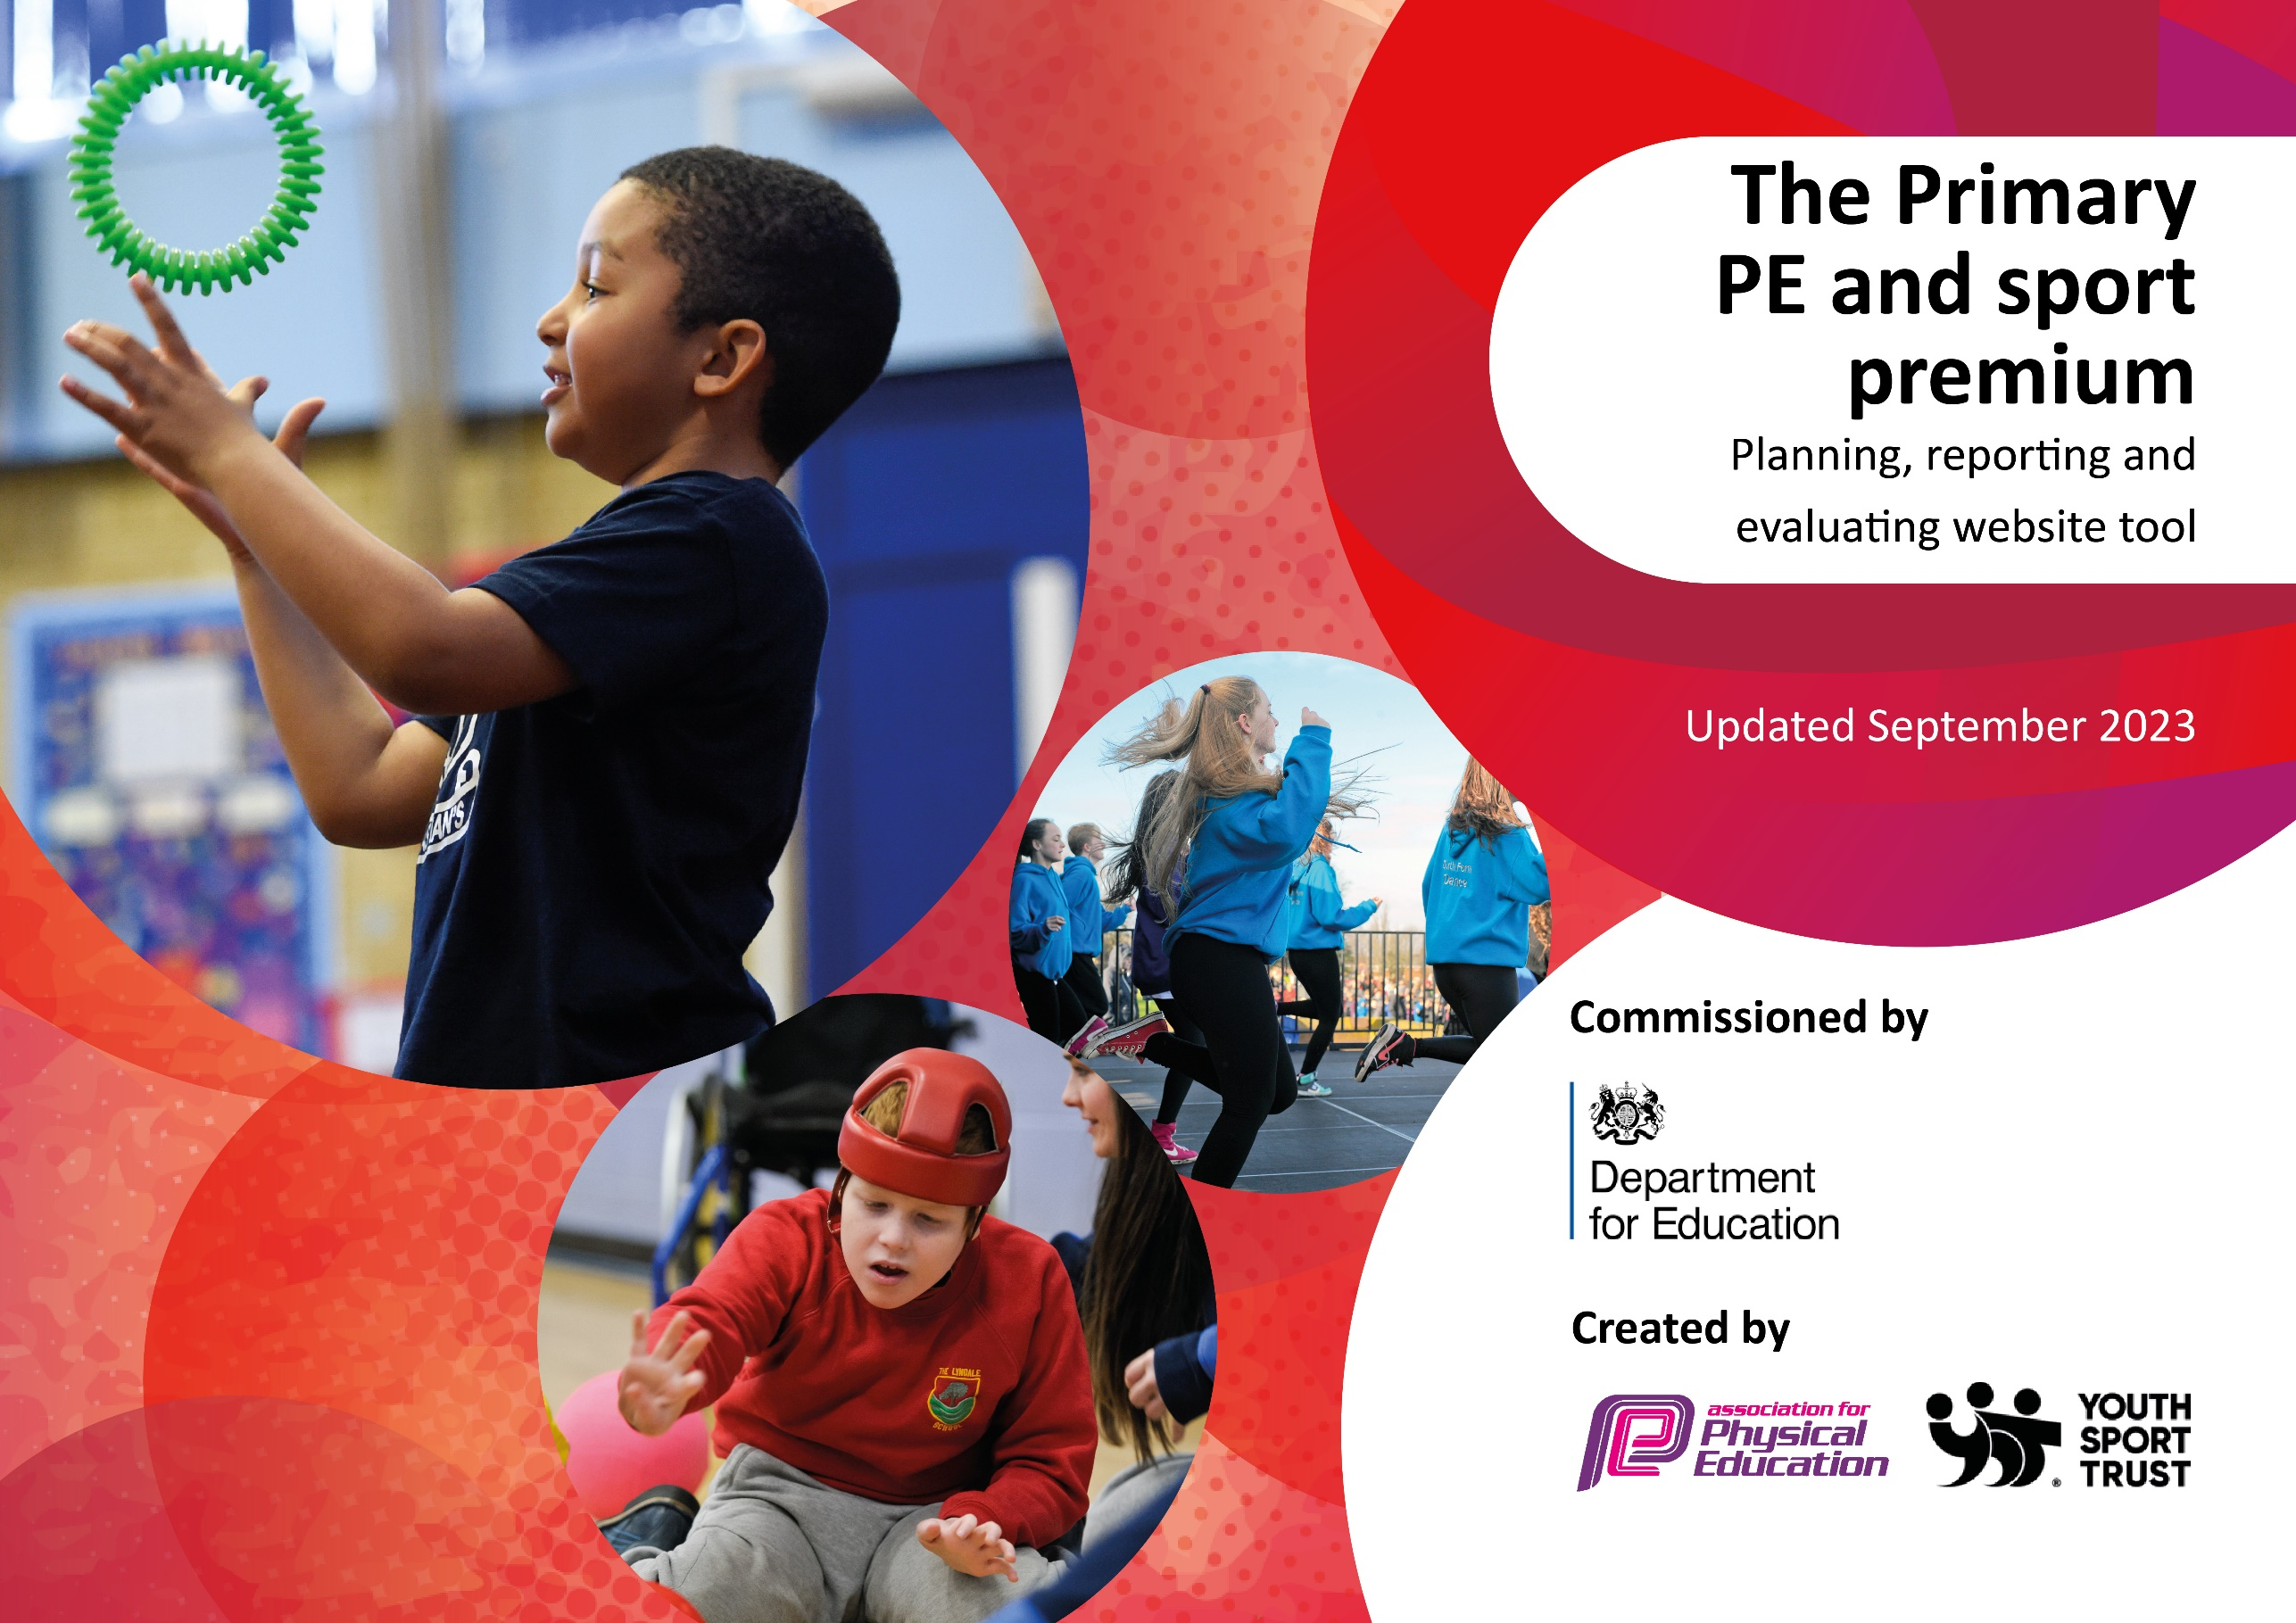

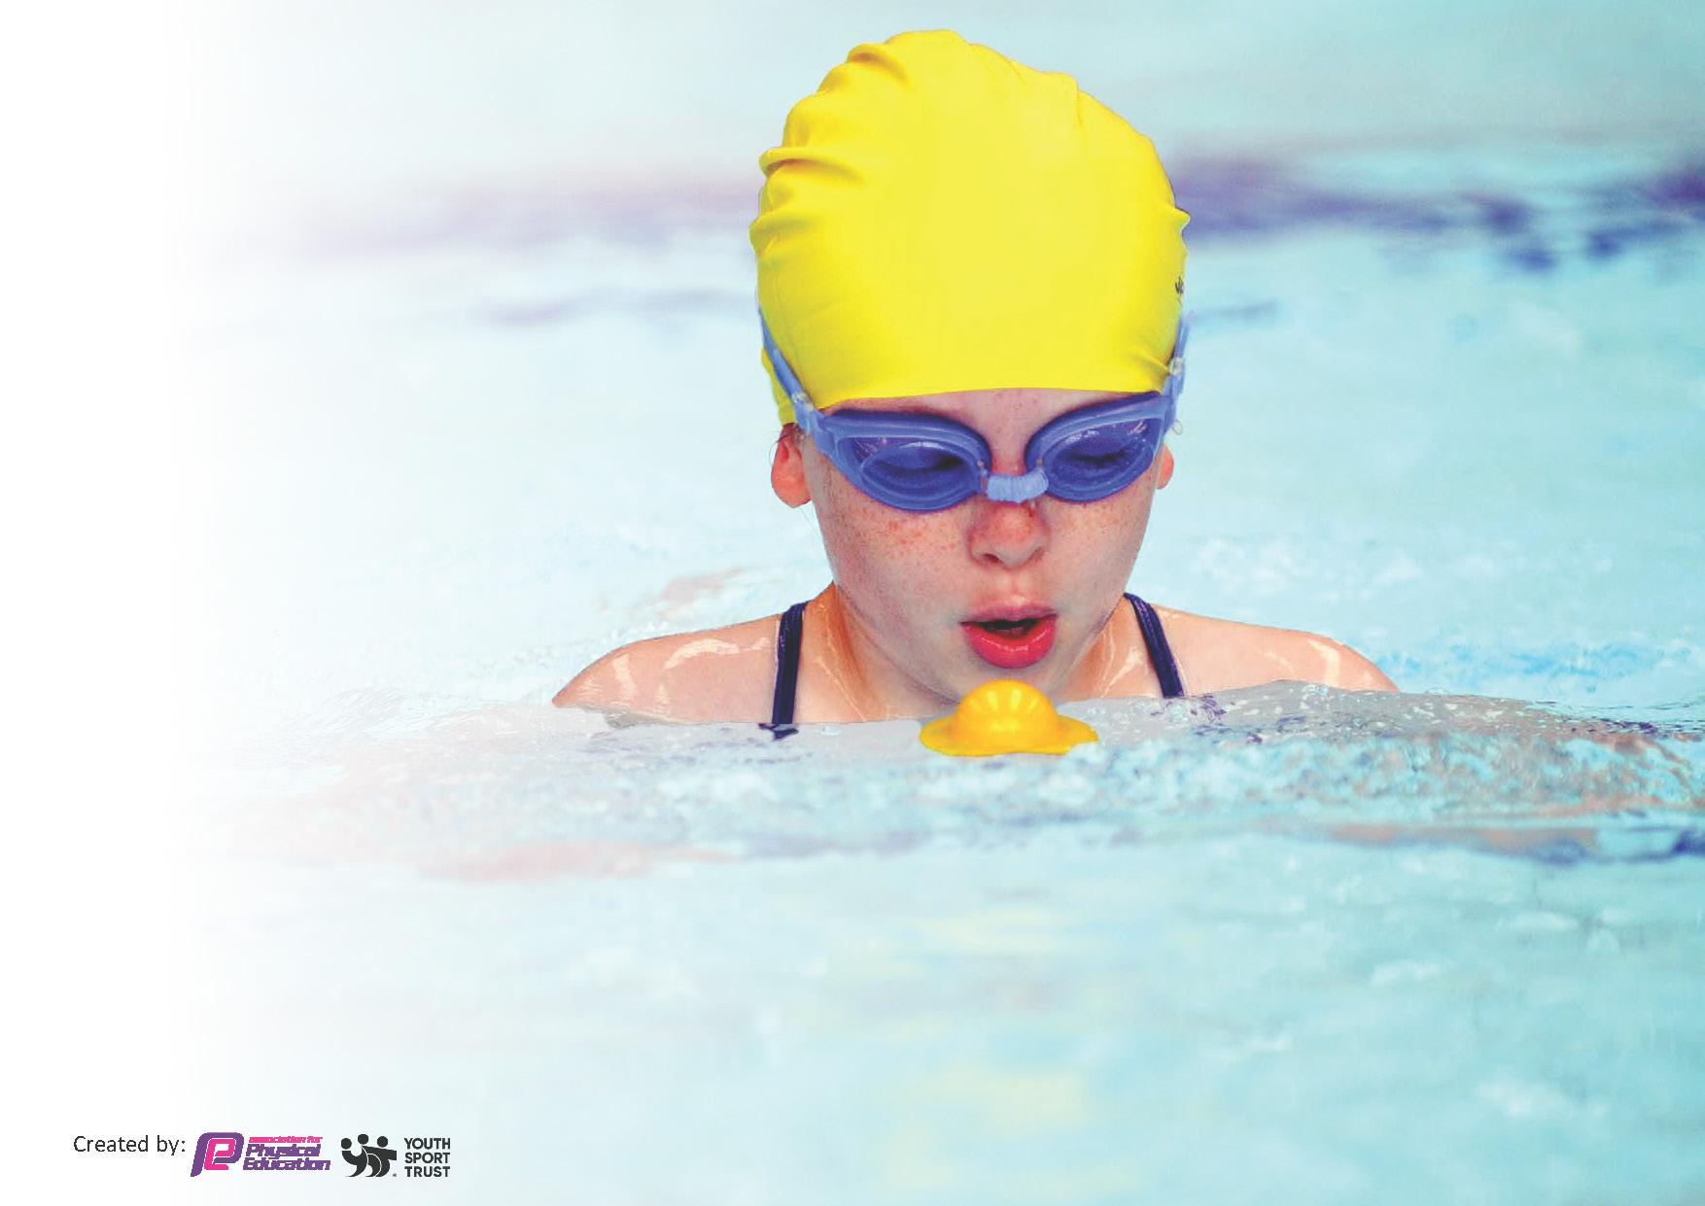
This template can be used for multiple purposes:
by:
- It enables schools to effectively plan their use of the Primary PE and sport premium
- It helps schools to meet the requirements (as set out in guidance) to publish information on their Primary PE and sport premium
- It will be an effective document to support Ofsted inspections enabling schools to evidence progress in Physical Education (PE) and evidence swimming attainment, which forms part of the PE National Curriculum. We would recommend schools consider
the Intent, Implementation and Impact of any spend, as examined within the Education Inspection Framework.

It is important that your grant is used effectively and based on school need.

Schools must use the funding to make additional and sustainable
improvements to the quality of the PE, School Sport and Physical Activity (PESSPA)
they offer. This means that you should use the Primary PE and sport premium to:

- Build capacity and capability within the school to ensure that improvements made now will benefit pupils joining the school in future years
- Develop or add to the PESSPA activities that your school already offers.

The Primary PE and sport premium should not be used to fund capital spend projects; the school’s core budget should fund these. Further detail on capital expenditure can be found in the updated Primary PE and sport premium guidance.

The Primary PE and sport premium guidance, outlines 5 key priorities that funding should be used towards. It is not

necessary that spending has to meet all the key priorities, you should select the priorities that you aim to use any funding towards.

Although completing this template is not a requirement for schools, schools are required to publish details of how they spend this funding. Schools must also outline what the impact this funding has had on pupils’ PE and sport participation and attainment and how any spending will be sustainable in the future. All funding must be spent by 31st July 2024.

The Department for Education has worked closely with the Association for Physical Education (afPE) and the Youth Sport Trust (YST) to develop this template and encourages schools to use it. This template is an effective way of meeting the reporting requirements of the Primary PE and sport premium.
Review of last year’s spend and key achievements (2022/2023)

We recommend you start by reflecting on the impact of current provision and reviewing your previous spend.

Activity/Action | Impact | Comments
- Pupil Voice through Sports Cabinet: We continued to develop pupil voice through our Sports Cabinet, which actively engaged students in identifying barriers to participation for reluctant children. The Sports Cabinet then took appropriate action to reduce those barriers, such as organizing targeted activities, providing additional support, and fostering inclusivity. This approach resulted in increased participation rates and greater enjoyment of physical activities among all students.  - Broadening Competitive Sporting Opportunities: We remained committed to expanding the breadth of competitive sporting opportunities offered to our students. Through partnerships with local schools and sports organizations, we increased the number of inter-school competitions, tournaments, and friendly matches. This allowed students to showcase their skills, fostered healthy competition, and encouraged a lifelong love for sports.  - Widening Range of Sporting Activities: In our pursuit of providing diverse physical activities, we further expanded the range of sports on offer to our pupils. This included introducing new sports clubs, exploring non-traditional activities, and ensuring a balance between team-based and individual sports. By offering a wider variety of options, we aimed to cater to the varying interests and abilities of our students, promoting inclusivity and enthusiasm for physical education.  - Continuing Professional Development (CPD) for Teachers: Recognizing the importance of continuous professional development, we ensured that all teachers received at least one-half term of CPD dedicated to physical education during the 2022- Pupil Voice through Sports Cabinet: We continued to develop pupil voice through our Sports Cabinet, which actively engaged students in identifying barriers to participation for reluctant children. The Sports Cabinet then took appropriate action to reduce those barriers, such as organizing targeted activities, providing additional support, and fostering inclusivity. This approach resulted in increased participation rates and greater enjoyment of physical activities among all students.  - Broadening Competitive Sporting Opportunities: We remained committed to expanding the breadth of competitive sporting opportunities offered to our students. Through partnerships with local schools and sports organizations, we increased the number of inter-school competitions, tournaments, and friendly matches. This allowed students to showcase their skills, fostered healthy competition, and encouraged a lifelong love for sports.  - Widening Range of Sporting Activities: In our pursuit of providing diverse physical activities, we further expanded the range of sports on offer to our pupils. This included introducing new sports clubs, exploring non-traditional activities, and ensuring a balance between team-based and individual sports. By offering a wider variety of options, we aimed to cater to the varying interests and abilities of our students, promoting inclusivity and enthusiasm for physical education.  - Continuing Professional Development (CPD) for Teachers: Recognizing the importance of continuous professional development, we ensured that all teachers received at least one-half term of CPD dedicated to physical education. | Pupil Voice through Sports Cabinet:  Impact: Empowering students through the Sports Cabinet led to a sense of ownership and involvement. Students became more proactive in identifying and addressing barriers to participation. This not only increased overall participation rates but also enhanced the enjoyment and engagement levels of students in physical activities.  Broadening Competitive Sporting Opportunities:  Impact: The expansion of competitive sporting opportunities exposed students to a broader spectrum of competition. This exposure encouraged healthy competition, skill development, and teamwork. It also instilled a lifelong passion for sports by allowing students to demonstrate their abilities and potential on a larger stage.  Widening Range of Sporting Activities:  Impact: Diversifying the range of sporting activities catered to the diverse interests and abilities of students. It promoted inclusivity by accommodating different preferences, whether team-based or individual sports. This increased enthusiasm for physical education by offering options that resonated with various students, ultimately contributing to a more active and engaged student body.  Continuing Professional Development (CPD) for Teachers:  Impact: Investing in the professional growth of teachers through CPD positively impacted the quality of physical education. Educators became more proficient, creative, and equipped to deliver effective lessons. This, in turn, enhanced the overall learning experience for students, fostering a deeper understanding and appreciation of physical education. | In summary, these actions collectively fostered a more inclusive, engaging, and effective physical education environment. Students were actively involved in shaping their experiences, had increased opportunities for competition and skill development, were exposed to a wider range of activities, and received instruction from teachers who were continuously improving their teaching methods. These initiatives contributed to a more holistic and beneficial physical education program for the students.

Key priorities and Planning
This planning template will allow schools to accurately plan their spending.

Action – what are you planning to do | Who does this action impact? | Key indicator to meet | Impacts and how sustainability will be achieved? | Cost linked to the action
Continue increasing daily physical activity of our EYFS children, particularly outdoor learning through new outdoor area.  Continue ensuring our vulnerable children are accessing physical activity beyond the curriculum, a short term course with a coach. | Early Years Foundation Stage  Vulnerable Children. | Key Indicator 1: Increased confidence, knowledge, and skills of all staff in teaching PE and sport.  Key Indicator 1: Increased confidence, knowledge, and skills of all staff in teaching PE and sport. | Regularly assess and maintain the outdoor area to ensure safety and suitability for EYFS children - Collaborate with EYFS staff to integrate outdoor activities and learning into daily routines - Seek feedback from EYFS children, staff, and parents on the impact of the new outdoor area - Monitor EYFS children's participation and progress in outdoor activities - Explore partnerships with local organisations or community resources to enhance outdoor learning opportunities  Continuously monitor and evaluate the progress and well-being of vulnerable children participating in physical activities - Collaborate with parents and external agencies to | No cost  £85 per Week
Continue to encourage more children (along with their parents) to participate in active travel to school to take advantage of additional opportunities to exercise during the day  Extend and increase our offer of extra-curricular clubs after school through the use of staff on role and external providers. Track and monitor the participation of clubs.  RH ACADEMY  Extend awareness and ensure children monitor daily activity through use of MOKI bands and further promote children's engagement. Children who achieve the most steps over the two week period will receive a certificate.  To actively encourage PESSPA and out of school activity through PE interactive noticeboard  Playground Leaders reintroduced across the phases with structured activities for all children to take part in. Children from Years 4/5/6 to be trained by the sports coach, using the PPP Leadership lessons.  Purchase, implement and review the Primary PE Planning platform to plan lessons, following the curriculum builder. Monitor the implementation of PPP to support staff. | All children and their families. | Key Indicator 1: Increased confidence, knowledge, and skills of all staff in teaching PE and sport.  Key Indicator 1: Increased confidence, knowledge, and skills of all staff in teaching PE and sport. Key indicator 4: Broader experience of a range of sports and activities offered to all pupils. Key indicator 5: Increased participation in competitive sport  Key Indicator 1: Increased confidence, knowledge, and skills of all staff in teaching PE and sport. Key indicator 2: The profile of PESSPA being raised across the school as a tool for whole school improvement  Key Indicator 1: Increased confidence, knowledge, and skills of all staff in teaching PE and sport.  Key Indicator 1: Increased confidence, knowledge, and skills of all staff in teaching PE and sport.  Key indicator 2: The profile of PESSPA being raised across the school as a tool for whole school improvement.  Key indicator 4: Broader experience of a range of sports and activities offered to all pupils  Key Indicator 1: Increased confidence, knowledge, and skills of all staff in teaching PE and sport. Key indicator 2: The profile of PESSPA being raised across the school as a tool for whole school improvement. Key indicator 3: Increased confidence, knowledge and skills of all staff in teaching PE and sport  Key indicator 4: Broader experience of a range of sports and activities offered to all pupils  Key indicator 5: Increased participation in competitive sport | provide ongoing support and resources for vulnerable children - Offer professional development opportunities for staff to enhance their understanding and skills in supporting vulnerable children - Advocate for the importance of inclusive physical activity within the school and wider community - Share success stories and best practices in supporting vulnerable children's access to physical activity  Maintain regular communication with parents and students regarding the benefits of active travel and ongoing initiatives - Continuously promote safe and active travel options through various platforms and events - Collaborate with local authorities to advocate for improved infrastructure and safety measures for active travel - Monitor and evaluate the impact of active travel initiatives on student participation and well-being - Explore partnerships with local organisations or sponsors to provide incentives or rewards for active travel participants  Regularly review and assess the popularity and effectiveness of current extra-curricular clubs - Seek feedback from students and parents to inform the selection and development of future clubs - Provide ongoing training and support for staff and external providers involved in running the clubs - Explore partnerships or sponsorship opportunities with local businesses or organisations to expand the range of available clubs - Monitor and evaluate the impact of extra-curricular clubs on student engagement, well-being, and personal development.  Regularly communicate the importance of daily activity to students and parents - Continuously promote the use of MOKI bands and provide ongoing support for students to monitor their activity - Collaborate with parents to encourage and reinforce the habit of daily activity monitoring - Evaluate the effectiveness of MOKI bands in promoting activity monitoring - Explore additional tools or technologies to enhance activity tracking - Collaborate with parents and students to develop personalised activity goals and action plans.  Maintain the PE interactive noticeboard with up-to-date information - Collaborate with local sports clubs and organisations to gather relevant resources - Involve students in the design and upkeep of the noticeboard - Monitor the utilisation of the PE noticeboard and track student participation in out-of-school physical activities - Seek feedback from students and parents on the impact of the noticeboard - Explore partnerships with local organisations to expand PESSPA opportunities for students  Sports coach to regularly train new cohorts of Playground Leaders to sustain the programme - Provide ongoing support and feedback to Playground Leaders - Collaborate with teachers and students to evaluate the impact of the programme and make necessary adjustments - Share best practices and success stories among staff and students - Explore opportunities for expanding the programme to include additional structured activities and opportunities for student input  Provide ongoing training and support for PE staff in utilising the Primary PE Planning platform - Regularly update and expand the range of resources available on the Primary PE Planning - Foster a culture of collaboration and sharing among PE staff to ensure continuous improvement - Gather feedback from PE staff on the effectiveness of the PPP platform and curriculum builder - Encourage PE staff to share their experiences and best practices with colleagues - Explore opportunities to customise and tailor the curriculum builder to the specific needs and context of the school | No cost

Intra Competition  Breakfast Club  The use of a sports coach to increase active participation  WCCC Chance to Shine Programme  EMAIL SENT  Continue to embed and implementation of Commando Joe character education.  SCOTT  Continue using the Active School Planner to make further actions as part of further improvement  To actively involve parents in PE decisions and encourage 30:30 /active lifestyles  Upcoming sports events to be discussed in school assemblies to generate excitement around future sporting competitions. SLT to timetable these into phase assemblies.  Continue to promote the profile of PE, School Sport and Physical Activity by incorporating intra-school competitions and personal challenges for children to complete.  Use of orienteering in school to increase activity both in PE (OAA) and cross-curricular.  Conduct a comprehensive assessment of the current PE provision and identify areas for improvement or development. PE Health Check.  Create links to clubs and actively encourage teachers to signpost children who excel or take an interest in sports taught in the curriculum  To ensure all staff are equipped with uniform to raise a high profile and importance of dressing appropriately for sport  Staff to nominate children after the end of a PE Unit demonstrating school values.  Continue to build links with the local School Games Officer.  PE Lead to observe all teachers delivering PE lessons to identify CPD needs.  Maintain Sports Game Gold Mark  Offer a wider range of activities both within and outside the curriculum in order to get more pupils involved such as: four square, boccia, fencing  Prioritise funding for travel to competitions. | . | Key Indicator 1: Increased confidence, knowledge, and skills of all staff in teaching PE and sport. Key indicator 4: Broader experience of a range of sports and activities offered to all pupils  Key indicator 5: Increased participation in competitive sport  Key Indicator 1: Increased confidence, knowledge, and skills of all staff in teaching PE and sport.  Key Indicator 1: Increased confidence, knowledge, and skills of all staff in teaching PE and sport. Key indicator 3: Increased confidence, knowledge and skills of all staff in teaching PE and sport  Key Indicator 1: Increased confidence, knowledge, and skills of all staff in teaching PE and sport. Key indicator 2: The profile of PESSPA being raised across the school as a tool for whole school improvement  Key indicator 3: Increased confidence, knowledge and skills of all staff in teaching PE and sport Key indicator 4: Broader experience of a range of sports and activities offered to all pupils  Key Indicator 1: Increased confidence, knowledge, and skills of all staff in teaching PE and sport.  Key Indicator 1: Increased confidence, knowledge, and skills of all staff in teaching PE and sport. Key indicator 2: The profile of PESSPA being raised across the school as a tool for whole school improvement  Key Indicator 1: Increased confidence, knowledge, and skills of all staff in teaching PE and sport.  Key indicator 2: The profile of PESSPA being raised across the school as a tool for whole school improvement  Key indicator 2: The profile of PESSPA being raised across the school as a tool for whole school improvement  Key indicator 2: The profile of PESSPA being raised across the school as a tool for whole school improvement  Key indicator 2: The profile of PESSPA being raised across the school as a tool for whole school improvement. Key indicator 3: Increased confidence, knowledge and skills of all staff in teaching PE and sport  Key indicator 2: The profile of PESSPA being raised across the school as a tool for whole school improvement  Key indicator 2: The profile of PESSPA being raised across the school as a tool for whole school improvement  Key indicator 2: The profile of PESSPA being raised across the school as a tool for whole school improvement  Key indicator 3: Increased confidence, knowledge and skills of all staff in teaching PE and sport  Key indicator 3: Increased confidence, knowledge and skills of all staff in teaching PE and sport  Key indicator 3: Increased confidence, knowledge and skills of all staff in teaching PE and sport  Key indicator 4: Broader experience of a range of sports and activities offered to all pupils  Key indicator 5: Increased participation in competitive sport | Establish an annual calendar of intra-competition events - Involve students in the planning and organisation of the competitions - Incorporate feedback from participants to continuously improve the events - Promote the values of fair play and sportsmanship throughout the school community - Monitor participation rates and feedback from students and staff regarding intra-competition events - Celebrate and recognise individual and team achievements - Explore opportunities for collaboration with other schools for inter-school competitions.  Collaborate with staff, students, and parents to continually improve the programme - Collect data on attendance, punctuality, and academic performance of students who attend Breakfast Club - Conduct surveys or focus groups to gather feedback from participants - Explore opportunities for partnerships with local organisations or businesses to support and expand the programme  Maintain a strong partnership with WCCC to ensure the continuity of the programme - Organise regular coaching sessions and matches with WCCC support - Explore opportunities for students to attend WCCC events or matches - Assess student participation rates and skill progression in cricket activities - Celebrate student achievements and success stories - Seek feedback from students, staff, and parents on the impact of the Chance to Shine Programme - Explore possibilities for expanding the partnership to include other cricket initiatives or opportunities  Integrate character education into the long-term curriculum plans - Train PE staff on the effective implementation of Commando Joe principles - Regularly evaluate and reflect on the impact of character education in PE and overall student development - Gather feedback from students, staff, and parents on the impact of character education - Monitor the application of character traits in different contexts - Share success stories and testimonials of character development through Commando Joe principles - Explore opportunities for cross-curricular integration of character education. Regularly assess and monitor the implementation of the Commando Joe character education program. - Offer refresher training sessions to reinforce teaching strategies and objectives.  Regularly review the Active School Planner reports and data to inform decision-making - Celebrate achievements and milestones in promoting physical activity - Engage students, staff, and parents in ongoing discussions on physical activity priorities and strategies - Conduct periodic evaluations of the effectiveness of the Active School Planner tool - Seek feedback from staff, students, and parents on their experience with the tool - Explore opportunities for collaboration with other schools or organisations using the Active School Planner to share best practices and lessons learned  Maintain regular communication with parents through newsletters, emails, or parent-teacher meetings - Involve parents in the planning and evaluation of PE initiatives - Collaborate with parent groups or associations to organise family-oriented physical activities - Conduct surveys or feedback sessions with parents to assess the effectiveness of parental involvement strategies - Share success stories and testimonials from parents to inspire and motivate others - Explore partnerships with local organisations to provide resources and opportunities for families to engage in physical activities together  Regularly review and update the schedule of sports events in school assemblies. - Seek feedback from students regarding their interest and preferences for future sports competitions. - Continuously promote and communicate upcoming events through various channels (e.g., newsletters, noticeboards).  Establish a system for regular intra-school competitions and personal challenges. - Provide ongoing support and resources for teachers to implement and monitor these activities. - Celebrate and showcase the achievements and progress of students participating in intra-school competitions and personal challenges.  Continue to Incorporate orienteering as an ongoing component of the PE curriculum and cross-curricular activities. - Explore opportunities to participate in orienteering events or competitions with other schools or organisations. - Provide professional development and training for staff to enhance their knowledge and skills in orienteering.  Develop an action plan based on the findings of the PE Health Check, outlining specific steps and strategies for improvement. - Regularly review and update the action plan based on progress and new insights. - Seek external support and guidance, if needed, to address identified areas of improvement.  Maintain and update a database or directory of local sports clubs and activities. - Regularly communicate and promote opportunities for students to join sports clubs. - Provide ongoing support and guidance to students who express interest in pursuing sports outside of the school curriculum.  Regularly review and update the supply and availability of PE uniforms for staff members. - Conduct training or workshops to educate staff on the importance of appropriate attire and professionalism in PE. - Foster a culture of adherence to the dress code and physical preparedness among staff through continuous reinforcement and communication.  Increased recognition and celebration of students' adherence to school values. - Reinforcement of positive behavior and character development in PE. Regularly acknowledge and celebrate the nominated students through recognition ceremonies, certificates, or displays. - Incorporate discussions and reflections on school values and character development within PE lessons. - Extend the nomination system to other areas of the school curriculum and extracurricular activities to foster a whole school approach to character development and recognition.  Increased participation in School Games events and competitions. - Expanded networking and partnership opportunities. Maintain regular contact and collaboration with the local School Games Officer. - Actively participate in School Games events and encourage student involvement. - Explore opportunities for joint initiatives and projects with the School Games Officer. - Share success stories and achievements from School Games events to inspire and motivate students and staff.  Identification of teachers' CPD needs related to PE delivery. - Customized and targeted CPD opportunities for teachers.  Regularly conduct observations to identify CPD needs and monitor progress. - Provide timely and appropriate CPD opportunities and support for teachers based on identified needs. - Evaluate the impact of CPD interventions on teachers' delivery of PE and adjust the support accordingly. - Establish a culture of ongoing professional development and reflective practice among all teachers, promoting the continuous improvement of PE delivery  Regularly review and update the application to meet the criteria for the Sports Games Mark Gold Award. - Share the application process and progress with staff, students, and parents to create awareness and generate support. - Continuously strive to maintain and improve the quality of PE and sport provision to continue meeting the standards required for the award.  Continue to increase the exposure to a broader range of subjects. Continually evaluate the success of the sports. Seek student feedback.  Increased participation in external competitions due to reduced financial barriers. Enhanced opportunities for students to showcase their skills and represent the school at various levels of competition. Promotion of inclusivity by ensuring students from all backgrounds have equal opportunities to travel and compete.  Regularly review and adjust the funding allocation process based on the availability of resources and the needs of students. Seek partnerships with local businesses or organizations to secure additional funding or sponsorship opportunities. An event tracker has been made, to ensure all events are booked with plenty of time to arrange and fund travel. | No Cost  No Cost

Key achievements 2023-2024
This template will be completed at the end of the academic year and will showcase the key achievements schools have made with their Primary PE and sport premium spending.

Activity/Action | Impact | Comments
- In order to enhance communication and feedback between teachers and students in PE lessons, we have implemented weekly feedback sheets for teachers to reflect on the pupils’ learning experiences and provide valuable insights. The feedback sheets cover aspects such as enjoyment levels, perceived difficulty of activities, and suggestions for improvement, including a section linked directly with our school values and pupil voice.  - Over the past academic year, we have successfully implemented various initiatives aimed at increasing participation in sports competitions among our students. Through the concerted efforts of our staff and the enthusiastic involvement of our students, we are delighted to report a significant rise in participation rates across all levels of competition. This increase in participation has had a profound impact on our school community, contributing to a more vibrant and inclusive sports culture. | - The introduction of feedback sheets has facilitated a more student-centered approach to PE teaching and learning. Teachers can now gain valuable feedback directly from students, allowing them to adapt and refine their teaching strategies to better meet the needs and preferences of individual learners. Moreover, students feel empowered to voice their opinions and utilise the pupil voice section of the feedback sheet and take ownership of their learning journey, leading to increased engagement and motivation in PE lessons.  - Skill Development: With more opportunities to compete in a variety of sports events, our students have experienced significant growth in their athletic abilities. Regular participation in competitions has provided them with invaluable opportunities to hone their skills, refine their techniques, and develop strategic thinking, contributing to their overall sporting proficiency and confidence.  - Improved Health and Wellbeing: Engaging in sports competitions has promoted physical activity and healthy lifestyles among our students. By actively participating in sports events, students have experienced the benefits of regular exercise firsthand, leading to improved physical fitness, enhanced mental wellbeing, and a greater appreciation for the importance of maintaining an active lifestyle.  - Community Integration: Our increased participation in competitions has facilitated greater integration with the wider community. Collaborating with local sports clubs and organisations has not only expanded our students' sporting horizons but has also strengthened our ties with the broader community. Through participation in external competitions, our students have had the opportunity to represent our school proudly while forging connections with fellow athletes from diverse backgrounds. | - Overall, the increase in participation in sports competitions has had a transformative effect on our school community, enriching the lives of our students and fostering a culture of excellence, teamwork, and sportsmanship. We are immensely proud of the achievements of our students and remain committed to nurturing their passion for sports and supporting their continued growth and development in the years to come.

Swimming Data
Meeting National Curriculum requirements for swimming and water safety.
Priority should always be given to ensuring that pupils can perform safe self-rescue even if they do not fully meet the first two requirements of the National Curriculum programme of study

Question | Stats: | Further context  Relative to local challenges
What percentage of your current Year 6 cohort can swim competently, confidently and proficiently over a distance of at least 25 metres? | % | Use this text box to give further context behind the percentage.  e.g., 30% - we are struggling to get pool space due to our local pool closing so we have had to use a much smaller local school pool. We have had to limit the number of pupils attending swimming lessons during one term which means some pupils have attended fewer swimming lessons than others.
What percentage of your current Year 6 cohort can use a range of strokes effectively [for example, front crawl, backstroke, and breaststroke]? | % | Use this text box to give further context behind the percentage.  e.g., Even though your pupils may swim in another year please report on their attainment on leaving primary school at the end of the summer term 2024

What percentage of your current Year 6 cohort are able to perform safe self-rescue in different water-based situations? | % | Use this text box to give further context behind the percentage.
If your schools swimming data is below national expectation, you can choose to use the Primary PE and sport premium to provide additional top-up sessions for those pupils that did not meet National Curriculum  requirements after the completion of core lessons. Have you done this? | Yes/No
Have you provided CPD to improve the knowledge and confidence of staff to be able to teach swimming and water safety? | Yes/No

Signed off by:

Head Teacher: | (Name)
Subject Leader or the individual responsible for the Primary PE and sport premium: | (Name and Job Title)
Governor: | (Name and Role)
Date:

